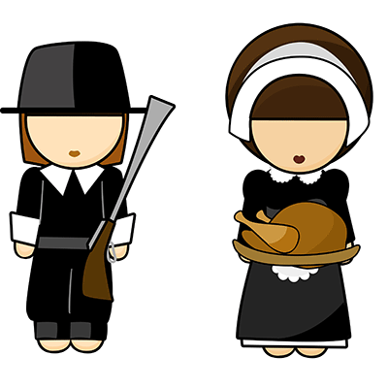
Kinder News
November 20, 2015
V.I.P.’s
Ian likes chocolate chip ice cream, bunnies, skateboards and his grandma and grandpa.
Imogen likes kittens, pink, going to her friend’s house and Barbies.
Noah likes mac and cheese, waffles, T-Rex dinosaurs and going to the beach.
Stephon likes spaghetti, going, to the circus and learning about dinosaurs.

THE FIRST THANKSGIVING FEAST
The children enjoyed acting out the story of the first Thanksgiving. They talked about the pilgrims boarding the Mayflower and traveling for 66 days before arriving at Plymouth Rock. The Native Americans helped them to survive in the New World. The Pilgrims invited them to enjoy a celebration that lasted three whole days and later became known as the First Thanksgiving. We talked about things that we are thankful for and wrote a new class book about those things.
Native American Songs
We have learned some great songs that your Kinders enjoyed singing.
INDIAN WARRIOR
I’m an Indian warrior, warrior,
Big Chief Indian warrior, warrior.
On my back a quiver, quiver,
Full of many arrows, arrows.
Hi, ho! Hi, ho! Hi!

INDIANS
An Indian wears a buckskin suit, Tom, tom, tom, tom, tom, tom.
He sometimes plays a little flute,
Toot, toot, toot, toot, toot, toot.
I’d like to live as Indians do and wear some feathers red and blue
Tom, tom, tom, tom, tom, tom
Toot, toot, toot, toot, toot, toot.

Language Arts Skills
This week we continued learning the correct sounds and letter formations for the letters /w/, /j/, /y/, /x/ and /k/.

A Pilgrim Went Looking For a Turkey
The Kinders made a great new book this week called A Pilgrim Went Looking For a Turkey. This book works with the prepositions through, in, between, up, and behind. Be sure to let your Kinder share this book with you. They are learning some wonderful skills that will help them as they continue to be readers.

Word of the week: you

Math
This week we have been using our balance scale to measure the weight of one object in comparison to another object to see which one is lighter or heavier. We are learning to use academic vocabulary as we make these comparisons. We also weighed objects to see how many pennies it weighed.

THANKSGIVING HOLIDAY
Remember that the children are off of school from November 23rd - 27th for the Thanksgiving holiday. We hope you have a wonderful and safe holiday with your family and friends. We will see you on the 30th.

