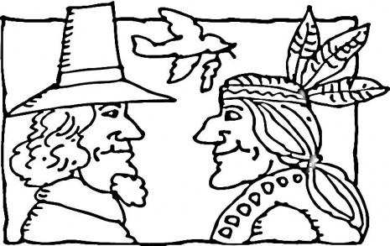
V.I.P.’s
Ava likes snowboarding, strawberry ice cream, penguins and her cowgirl costume.
Brooklyn likes bananas, Gilroy Garden, Sofia the Great, purple, gymnastics and riding big roller coasters
Hannah likes kittens and dolphins, pink and purple, eating sushi, being a five star listener and playing with friends.
Jayden likes going to Legoland, circles, McDonalds, cheetahs, limes and eating pizza.

The First Thanksgiving
We have been preparing for our Thanksgiving feast next week by getting our Pilgrim and our Native American costumes ready. They have enjoyed hearing the story of the first Thanksgiving and are busy deciding which character they want to be. We also made drums and rain sticks to use in our singing of the songs this month.

Language Arts Skills
This week we started with more sounds to practice: /l/, /r/, /u/ and /k/. We continue to do chaining

where we change one letter each time For example, bag, rag, tag, tap, top, hop, hog, log. Some new simple phrases your child should be able to read and write are: rip it, big rig, big red dog, cat and rat, rap on it, it can rot, etc… Remind them that we put a two finger space between the words.

Word of the week: have
Have you got a froggy
Sitting in a pond?
H-A-V-E, have.
H-A-V-E, have.
Math
This week we have been working on longer and shorter. It is important for the children to be able to talk about the different lengths like this: My 5 stick is longer than my 3 stick. My 3 stick is shorter than my 5 stick..

CONFERENCES
We have finished up our conference week and we want to thank you for the opportunity to sit down one- on -one and talk about your child’s progress. We appreciate you taking the time and effort to make that happen.
