Kinder News
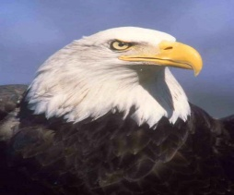
V.I.P’s
Leylani likes: dolphins, pink and choc. ice cream.
Chloe likes: broccoli, zoo legos and dolphins.
Kaliegh likes: gummy bears, Hello Kitty and #200.
Language Art Skills:
We have been practicing digraphs th, sh, ch, qu and ng. We read stories with these digraphs and practiced their sounds in words.
Listening and Learning:
This week we wrapped up our unit on Kings and Queens by reading some fairy tales like Princess and the Pea, Cinderella, and Snow White.

Math:
This week we started working on turning number bonds into number sentences. We learned that a number sentence can be written whole-part/part or part/part-whole. The equal sign means that the equation is balanced.
Ex… 2+4=6 or 6=2+4
America:
We made a book this week called America I Love You! We learned symbols for our country and about two important presidents in history.
**Reminder**
No school Feb. 16-Feb. 20 for Winter Break
