Kinder
News
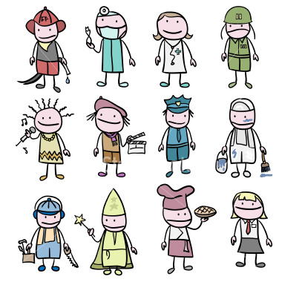
Occupations:
This week we read fiction and non-fiction books about different occupations. We completed books that we made about what we would look like with different occupations. Look for this fabulous book at Open House night.

Skills:
This week we have learned more tricky words that were in our Zack and Ann readers. The kids are great detectives at finding those tricky words everywhere. We also practiced writing them.
Math:
We practiced counting groups of ten to count to 100 and we practiced finding teen numbers in larger numbers.
Looking Ahead:
*Wed. May 11
-Open House 6-7:15
*Fri. May 20
-Kinder Olympics-Come watch the fun!
Garcia/Clark 8-9am
Branch/Page 9:30-10:30
*Fri, May 27
- Kinder “Water Play Day”

