V.I.P.’s
Kinder News
September 4, 2015

Catie- likes the pet store, riding horses
and strawberries
Lucas- likes the color red, swimming, mac and cheese
Grace- likes painting, pesto pasta
and panda bears
All about me week!
This week, we have talked about ourselves. Each of us is unique and special. We have read stories, made books and self-portraits to celebrate “ME!”
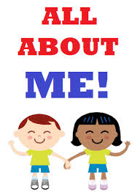
“I Am Me” and other LITTLE BOOKS
We hope you have been enjoying the little books your kinder has been making. These are great books to practice their reading skills at home. Here are some characteristics that make these books great for our early readers:
- Familiarity with the content
- Repetitive text (“I see…”)
- Use of high frequency words
- Simple text for your child to point
and read along.
- Picture matches the words
Language Arts
Skills Strand- This week we continued to practice segmenting words in sentences. We tracked left to right and practiced holding our writing utensil with a tripod grip.

Listening & Learning- This week we continued learning about nursery rhymes. We have talked about characters and events, identified rhyming words and we can now recite Nursery Rhymes. Sing a few with us, it helps build memory capacity, identify patterns in repeating lines and helps our ears learn to identify rhyming words.

Math
This week we sorted categories, counted to 5 in different configurations, math drawings and expressions.

