Kinder News
January 22, 2016
V.I.P.’s
Olivia likes Piggie and Elephant Books, red apples, and December.
Daniel likes soup, snakes, and red.
Noah L. likes Disney Infinity, being with his sister Rebekah, and strawberries.
Dakota likes bunnies, Disneyland, and Winter.

Snowflakes and Snowmen
We had a fun week with making snowflakes and illustrating our snowman book, Big, Bigger, Biggest. We hope you take the time to enjoy the book with your children.
We also had a listening test where we had to illustrate the story our teacher read to us. We are getting to be better listeners all the time.

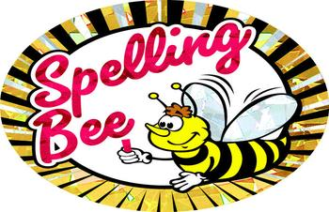

Spelling Bee
The Nordstrom Spell-a-thon is quickly approaching. Look for the Kinder word list going home soon! Try having your child pick 3 or 4 words per day to practice writing 5 times each. Here is a preview…

log, bed, pig, dog, cat, van, man, mom, tag, mad, net, rat, pen, mat, dig, see, like, the, go, my

Language Arts Skills
This week we started on Unit 7. We continue blending four and five sound words together. The children need to be able to chain these words together as well as write them. (chin> thin > shin > pin > pan > path > math > moth). This week we introduced three new digraphs /ch/, /sh/ and /th/. Have the kinders give you some words that start or end with these sounds.

Listening and Learning
We have just started our domain on kings and queens. The children drew pictures of how they would look in royal robes with a scepter and an orb and a crown upon their heads. See if they can tell you some of the advantages and disadvantages of being royalty.

Math
This week we have continued with number bonds up to 7. Have the children look carefully to make sure their number paths go to the correct circles. This is still very new to them.

