**Kinder News**

**September 9, 2016**

**V.I.P.’s**

Jeff Perryman likes the color red, penguins, swimming, archeology, going to Jamaica and eating lentils.,

Madison Pfeffer likes the colors pink and purple, gymnastics, Elsa books, wearing dresses and eating spaghetti.

Mason Charles likes the color red, going to Legoland, cats, police officers and eating chicken nuggets and pizza.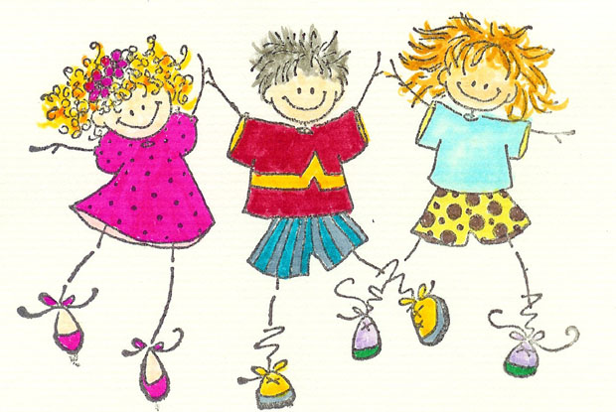

**Me Week**

This week we talked about how important each child in our classroom is and some of the characteristics that make them unique. In some things the children are alike and in other ways they are different. We did another small book called I Am Me. We hope you are reading these books with your children and saving them in a special spot because they will be able to read them independently very soon. A shoe box or a Ziploc baggie is a great storage spot. That way they children can practice reading them again and again.

**Language Art**

Skills Strand-This week we have continued working on differentiating between sounds and have started counting words in sentences with clapping and holding up fingers. We practiced drawing circles, diagonal lines, horizontal and vertical lines. We are learning about top, bottom, left, right and middle for positional words. We also continue to practice tracking left to right as all good readers do!

**Word of the Week--me**

Listening and Learning—We continue to practice nursery rhymes and are working on our listening and speaking skills. The children are really working hard at this.

**Math**

We continue practice with lots of counting and we have started recording an equal group of items. The children are also talking about their discoveries that they make as they talk about attributes. We have also started our questions of the day!

**Thanks for coming to Back to School Night this week. You are sending the message to your children that school is important! We hope that we answered many of your questions and we are looking forward to a wonderful year together.**

**Kinder News**

**September 11, 1915**

**V.I.P.**

Chase likes the color blue, jaguars and Batman.

Kahlia likes the color turquoise, hula dancing and hearts.

Liam likes going to Disneyland, the color green, cheeseburgers and super heroes.

Mrs. Page likes teaching school, going to the beach and spending time with her family.

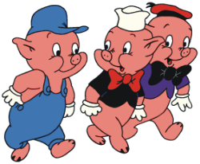

**The Three Little Pigs**

This week we did The Three Little Pigs. We heard many versions of this story and enjoyed them all. We made headbands of our favorite character and acted out the story in our classrooms. We retold the story in a book that we illustrated, complete with a wolf puppet. Please help us find a safe spot to keep this book so that we can read it again and again. It is a great story to practice retelling as we work on sequencing.

**Language Art**

Skills Strand-This week we have started syllable blending as well as sound blending. We are also learning blending gestures. We practiced cup lines, hump lines, zigzag and curvy lines. We continue to practice tracking left to right.

**Word of the Week--I**

Listening and Learning—We heard fables this week. The kinders are learning that a fable is a story with a moral in it. The children know that a moral is a lesson that the characters learn.

**Math**

We continue practice with counting and recognizing numbers to 5. We have also started simple word problems with addition.

**Thanks for coming to Back to School Night this week. You are sending the message to your children that school is important! We hope that we answered many of your questions and we are looking forward to a wonderful year together.**

**FAMILY FUN NIGHT**

We hope many of you are planning on coming to the Family Fun Night on September 18th. It is always a fun-filled evening. It is a great way to enjoy the wonderful Nordstrom community.



**Kinder News**

**October 10, 2014**

**V.I.P.**

Gabby likes going to Disneyland, her Elsa and Anna dolls and horses.

Agustin likes going swimming, eating pizza and the color green.

Arjun likes chocolate ice cream, Pokemon cards, playing soccer and basketball and cinnamon bread.



**Apples Week II**

We finished off our second week of the study of apples. We made torn paper apples, apple houses as well as labeled the different parts of an apple and graphed our favorite type of apples. We are apple experts now!

**A special thanks to the wonderful volunteers who went to Gizdich Ranch with us this week. We appreciate you giving of your time and talents to spend the day with us.**

**Language Art**

Skills Strand-This week we continued oral blending and sound review on the sounds we have learned (a, i, o, t, m, d, c, k). The children have been practicing pocket chart chaining for reading as well as spelling. They should be able to do two to three letter real words as well as silly words in a reading or a spelling chain. An example would be: at>mat>mad>mid>did>dad.

Listening and Learning—We listened to folktales this week which are stories that were originally passed down orally. The kinders should be able to tell you that fiction stories come from someone’s imagination. We continue talking about the ***characters*** in the story, the ***setting*** of where the story takes place and the ***plot*** or the order of events in a story. Discuss the ***characters, setting*** and ***plot*** in the stories you read at home.

**Math**

We continue practice with counting forward and backwards within 10. We have also been doing math stories with one more and one less in these math stories.

C:\Users\Clark Family\AppData\Local\Microsoft\Windows\Temporary Internet Files\Content.IE5\BNLPLXEY\MC900237283[1].wmf

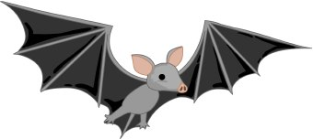

Kinder News

October 16, 2015

**V.I.P.’s**

Arya likes going to Gilroy Gardens, pepperoni pizza, playing with dad and Star Wars toys.

Jules likes eating pasta, zebras, elephants, Barbies, red apples and the color magenta.

Kaitlin likes **all** the princesses, tomato soup, ice cream, giraffes, Starbursts and the color pink.

C:\Program Files\Microsoft Office\MEDIA\CAGCAT10\j0305493.wmf

**PUMPKINS**

We talked a lot this week about the life cycle of a pumpkin. The kinders should be able to talk about the seed, the sprout, the plant, the vine, the flower, the green pumpkin, the orange pumpkin and back to the seeds again. We also made a great project called The Pumpkin House where we put some of our friends in. It has been made into a book in some of the classes.

**Language Arts Skills**

This week we continued practicing segmenting words into phonemes. We still blend words each day as well. We continue to review the sounds we have learned so far this year. The new sounds we worked on this week are /n/, /h/, /s/, and /f/. If your child is not able to do these new sounds with ease, we would ask that you help with some additional practice at home.

We started our testing for the report cards this week and we are impressed with how much the children have learned in the last 45 days. Thank you for your continued support at home.

**Math**

This week we have been working on counting down from ten. We use the terms counting down, counting backwards, and one less. It is important for the children to be able to say 10, one less than 10 is 9. 9, one less than 9 is 8, etc.

**Word of the Week: to**

**Song:**

**To is written with a t and then an o**

**T0, to**

**To is written with a t and then an o**

**T0, to**

**First you make a /t/, /t/, t**

**Then you make an /o/, /o/, o**

**To is written with a t and then an o**

C:\Program Files\Microsoft Office\MEDIA\CAGCAT10\j0305493.wmf

Kinder News

October 31, 2014

**V.I.P.’s**

Bryan Werkman likes going to Maui, Ironman, the stegosaurus dinosaur and his mom and dad.

Logan likes Jake and the Neverland Pirates, elephants, German Shepherds, Disneyland and the color blue.

Sidney likes likes green apples, chocolate chip cookies, the Frozen movie and the color purple.

**BONES**

We talked a lot this week about the bones in our bodies. We know we have 206 bones in our skeleton. We know that some bones help our bodies move and that other bones protect our organs. We also know that as we grow older, our skeleton grows bigger. We practiced matching skeletons with their correct outer covering.

**Language Arts Skills**

This week we continued practicing segmenting words into phonemes. We reviewed the 16 sounds we have learned so far this year and continued reading and spelling chains of one-syllable short vowel words. We are learning to distinguish between similarly spelled words by identifying the sounds of the letters that differ, e.g., peg and pig, pin and pen. We also started reading big books where we are reading two and three word phrases. It is fun to learn these new skills.

**Listening and Learning**

We have continued on with our domain about living things. This week we learned about pollination, fruit and heard the story of Johnny Appleseed. We also learned about evergreen and deciduous trees.

**Math**

This week we have started working on the 3-D shapes cylinders, cones, cubes and spheres. We are learning how to recognize these solid shapes and also learning the positional words *above, below, beside, in front of, next to*, and *behind*.

**If you had the chance to read this Kinder News, have your child draw one 3-D shape with their name of it and they will get a sticker from their teacher.**

**C:\Users\Clark Family\AppData\Local\Microsoft\Windows\Temporary Internet Files\Content.IE5\KON83EHB\MC900353768[1].wmf**

**Kinder News**

November 7, 2014

**V.I.P.’s**

Emily Madison likes strawberry cake, elephants and dolphins, playing with dolls in her dollhouse and pretty reds and blues.

Thomas likes golden apples, strawberry ice cream, corn and playing his SpongeBob game.

Vienna likes the color pink, circles, fried rice, fish, her Elsa and Anna dolls and The Lego Movie.

**Fall**

We talked a lot this week about the season of fall. We taught them a very simple song which goes like this: Winter, Spring, Summer Fall, four seasons in all. The children made leaf rubbings, leaf graphings and watercolored as well as sponge painted leaves. We learned about three types of leaves, lobed, round and toothed. We also made 4 season trees. Let the kinders share some of the knowledge they have gained this week. We hope you take the opportunity to enjoy a fall walk with the children this weekend and enjoy the beauty of nature with them.

**Language Arts Skills**

This week we continued practicing segmenting words into phonemes. We also have been working on reading two and three word phrases. A great activity at home would be to have your child practice writing simple phrases such as the following: men in van, sit on mat, pig in pen, tap on it, sad man, hot ham, mom did it, dad can mop, etc… Remind them that we put a two finger space between the words.

**Math**

This week we finished up our unit on 2-D and 3-D shapes. We want the children to remember that some shapes are flat shapes and some are solid shapes. Point these shapes out when you are with your kinder and see if they can continue to identify them. We will continue to revisit these shapes through the year.

**BROWN SONG:(Bingo)**

There is a color we all know.

Can you guess what it is?

B-r-o-w-n, B-r-o-w-n, B-r-o-w-n

That’s how you spell brown.

Teddy bears and squirrels are brown.

Autumn leaves are too.

Chocolate candy is always brown.

Chocolate cake is always brown.

Chocolate milk is always brown.

I like brown, don’t you.

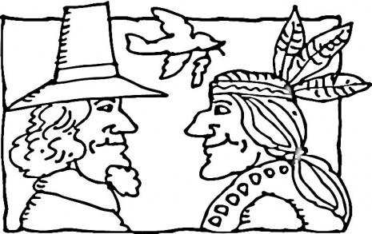

**November 13, 2015**

**V.I.P.’s**

Ava likes snowboarding, strawberry ice cream, penguins and her cowgirl costume.

Brooklyn likes bananas, Gilroy Garden, Sofia the Great, purple, gymnastics and riding big roller coasters

Hannah likes kittens and dolphins, pink and purple, eating sushi, being a five star listener and playing with friends.

Jayden likes going to Legoland, circles, McDonalds, cheetahs, limes and eating pizza.

**The First Thanksgiving**

We have been preparing for our Thanksgiving feast next week by getting our Pilgrim and our Native American costumes ready. They have enjoyed hearing the story of the first Thanksgiving and are busy deciding which character they want to be. We also made drums and rain sticks to use in our singing of the songs this month.

**Language Arts Skills**

This week we started with more sounds to practice: /l/, /r/, /u/ and /k/. We continue to do chaining

where we change one letter each time For example, bag, rag, tag, tap, top, hop, hog, log. Some new simple phrases your child should be able to read and write are: rip it, big rig, big red dog, cat and rat, rap on it, it can rot, etc… Remind them that we put a two finger space between the words.

**Word of the week: have**

Have you got a froggy

Sitting in a pond?

H-A-V-E, have.

H-A-V-E, have.

**Math**

This week we have been working on longer and shorter. It is important for the children to be able to talk about the different lengths like this: My 5 stick is longer than my 3 stick. My 3 stick is shorter than my 5 stick..

**CONFERENCES**

We have finished up our conference week and we want to thank you for the opportunity to sit down one- on -one and talk about your child’s progress. We appreciate you taking the time and effort to make that happen.

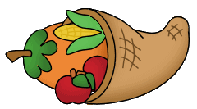

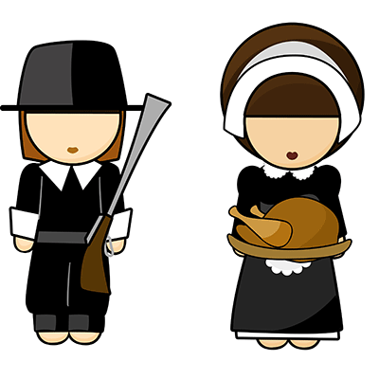

Kinder News

November 20, 2015

**V.I.P.’s**

Ian likes chocolate chip ice cream, bunnies, skateboards and his grandma and grandpa.

Imogen likes kittens, pink, going to her friend’s house and Barbies.

Noah likes mac and cheese, waffles, T-Rex dinosaurs and going to the beach.

Stephon likes spaghetti, going, to the circus and learning about dinosaurs.

**THE FIRST THANKSGIVING FEAST**

The children enjoyed acting out the story of the first Thanksgiving. They talked about the pilgrims boarding the Mayflower and traveling for 66 days before arriving at Plymouth Rock. The Native Americans helped them to survive in the New World. The Pilgrims invited them to enjoy a celebration that lasted three whole days and later became known as the First Thanksgiving. We talked about things that we are thankful for and wrote a new class book about those things.

**Native American Songs**

We have learned some great songs that your Kinders enjoyed singing.

*INDIAN WARRIOR*

I’m an Indian warrior, warrior,

Big Chief Indian warrior, warrior.

On my back a quiver, quiver,

Full of many arrows, arrows.

Hi, ho! Hi, ho! Hi!

*INDIANS*

An Indian wears a buckskin suit, Tom, tom, tom, tom, tom, tom.

He sometimes plays a little flute,

Toot, toot, toot, toot, toot, toot.

I’d like to live as Indians do and wear some feathers red and blue

Tom, tom, tom, tom, tom, tom

Toot, toot, toot, toot, toot, toot.

**Language Arts Skills**

This week we continued learning the correct sounds and letter formations for the letters /w/, /j/, /y/, /x/ and /k/.

**A Pilgrim Went Looking For a Turkey**

The Kinders made a great new book this week called A Pilgrim Went Looking For a Turkey. This book works with the prepositions *through, in, between, up, and behind.* Be sure to let your Kinder share this book with you. They are learning some wonderful skills that will help them as they continue to be readers.

**Word of the week: you**

**Math**

This week we have been using our balance scale to measure the weight of one object in comparison to another object to see which one is lighter or heavier. We are learning to use academic vocabulary as we make these comparisons. We also weighed objects to see how many pennies it weighed.

**THANKSGIVING HOLIDAY**

Remember that the children are off of school from November 23rd - 27th for the Thanksgiving holiday. We hope you have a wonderful and safe holiday with your family and friends. We will see you on the 30th.

C:\Users\Clark Family\AppData\Local\Microsoft\Windows\Temporary Internet Files\Content.IE5\8EX76L7N\MC900370300[1].wmf

Kinder News

December 12, 2014

**V.I.P.’s**

Ainsley likes sushi, unicorns, black cats, Christmas dresses and Arizona.

Daanish likes cars, horses, dolphins, ladybugs, going to the beach with his family and the color orange.

Tristan K. likes the season of winter, killer whales, the Star Wars rebels, going to Chuck E. Cheese and blue.

**FARMS**

We finished up our farm books that we have been making in class and also did our farm assessments. We hope you take the time to enjoy the book with your children.

**Language Arts Skills**

This week we started on Unit 6 in our skills. We have started with blending four-Sound Words together with initial consonant clusters. The children are also doing reading in big books. You will be receiving a paper copy of all the stories that we read in class. We hope you will keep these and let your children practice reading them to you. We tell them all the time that the more they practice reading, the better readers they will become. The students also learned that an ‘s’ at the beginning of a word will almost always be sounded /s/. However, in other positions in a word, especially at the end of words, the letter ‘s’ is sometimes pronounced /z/.

**Listening and Learning**

We have finished up our domain on farm animals and farms. This week we learned about the different jobs the farmers have to do during the different seasons of the years. We learned about fertilization, pests, crop dusters, etc.... We also learned about the process of getting crops to processing plants and then to the supermarkets.

**Math**

This week we have been making comparisons within 10. The children have been using the words more than, fewer than and the same as. They are also relating more and less in length and comparing sets informally using more, less, and fewer. These are great words to put in your conversations with your children at home.

**PAJAMA DAY**

Remember that next Friday, December 19th, is the school-wide pajama day. Everyone is invited to wear warm pajamas at school that day. It is enjoyed by all.

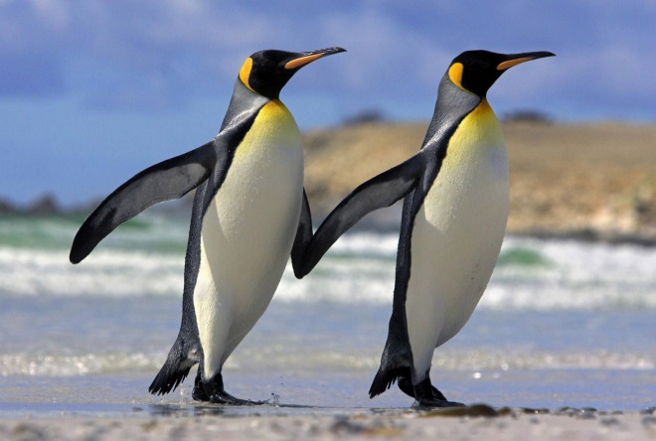

Kinder News

January 15, 2016

**V.I.P.’s**

Ayann likes the color red, squares, tigers and playing with his friends.

Ava likes pink and purple, chocolate ice cream and the princess Belle.

Dakota likes baking with her mom, purple, spaghetti and bunnies.

Brielle likes grilled cheese sandwiches, the snow and coloring.

**Word of the Week Song: play**

**P-l-a-y play**

**P-l-a-y play**

**Let’s all play now**

**Let’s all play now**

**P-l-a-y play Hey!**

**Color of the Month Song: Blue**

Tune: The Farmer in the Dell

B-L-U-E spells blue.

B-L-U-E spells blue.

Hi, Ho, did you know

B-L-U-E spells blue.

The big sky is blue.

The ocean is too.

Hi, Ho did you know

B-L-U-E spells blue.

**Lanugage Arts**

We have finished up United 6 in our Amplify Series. The children should know all the letter names and sounds by this time of the year and are comfortable in blending 4 and 5 sounds in a word together. We have also been practicing on being able to hear when words rhyme. This is a fun activity for you to do in the car with them. The more they practice hearing the rhyming in words, the easier it will be for them.

**PENGUINS**

We have completed our two week study of penguins. The kinders have learned many new facts about this interesting bird that cannot fly. We hope you take the time to let your child talk about some of the new vocabulary/information that they have learned over the last couple of week. The kinders were able to watch penguins being feed through a webcam at the California Academy of Sciences. The African penguin colony feeding happens at 10:30 am if you want to pull it up to enjoy with your children again.





Kinder News

January 23, 2015

**V.I.P.’s**

Bryan Lack likes red and black, Spiderman, Transformers, building with legos and going to Peru.

Genelle likes unicorns, quesadillas, flowers, Mexico and Jadey, her dog.

Ruby likes the color pink, going to the beach, flamingos, blueberry pie, evergreen trees and her dog shirt.

**Snowflakes and Snowmen**

We had a fun week with making snowflakes and illustrating our snowman book, *Big, Bigger, Biggest*. We hope you take the time to enjoy the book with your children.

We also had a listening test where we had to illustrate the story our teacher read to us. We are getting to be better listeners all the time.

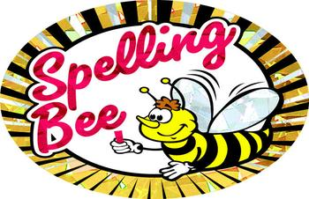

**Spelling Bee**

We finished up the spell-a-thon this week. The kinders that went to the second round all won medals and we had one awesome speller who took home the trophy. Thank you all for your generous donations towards the school fundraiser and the time you spent helping your child be ready for the spelling bee.

**Language Arts Skills**

This week we started on Unit 7 in our skills. We continue blending four and five sound words together. The children need to be able to chain these words together as well as write them. This week we introduced three new digraphs /ch/, /sh/ and /th/. Have the kinders give you some words that start or end with these sounds.

**Listening and Learning**

We have just started our new domain on kings and queens. The children drew pictures of how they would look in royal robes with a scepter and an orb and a crown upon their heads. See if they can tell you some of the advantages and disadvantages of being royal.

**Math**

This week we have continued with number bonds up to 7. Have the children look carefully to make sure their number paths go to the correct circles. This is still very new to the kinders but they are working hard at it.



**KINDER NEWS**

February 12, 2016

**V.I.P.’s**

**Alicia** likes dogs, riding bicycles and chicken and spaghetti.

**Evon** likes chicken noodle soup, snakes and the color pink.

**Gurveer** likes playing with his Transformer toys, going to Disneyland, chocolate and eating Mexican food.

**Tyler** likes sharks, chicken nuggets, carrots and going to the Boardwalk.

**WORD OF THE WEEK: she**

**Yippy ti-yi-yah**

**spelling she is so easy,**

**s-h-e, s-h-e, s-h-e, she**

**Yippy ti-yi-yah**

**spelling she is so easy,**

**s-h-e, s-h-e, s-h-e, she**

**LANGUAGE ARTS SKILLS**

We are finishing up Unit 7 this week where we have been learning the digraphs of ch, sh, th, qu, and ng. The children have been working hard on learning these new sounds and practicing them in their reading book, Seth. We hope you are reading the paper copies that are being sent home in your child’s homework. As they read these stories, their reading confidence will grow.

We have had fun talking about kindness as we prepared to celebrate Valentine’s Day. The children made a new class book called, A Heart For You. The children made fun hug bugs, slug bugs and valentine frogs.

**Math**

The kinders have been working hard on their addition sentences and understanding the correct place to put the numbers. Remember they can be written different ways:

_____ is _____ and ________

_____ = _______ t _________

______ and ______ = ________

______ t _______ is _________

We started on our subtraction practice this week as well.

**Pink**

Tune:Jingle Bells

Cotton Candy

Fat pink pigs

Girls with sock and bows

P-I-N-K, P-I-N-K

That is how it goes

Bubble gum

Valentines

These are all pink too

Pink icing and pink balloons

We can spell, can you?

**Spelling Bee**

We hope you are busy practicing the spelling words with your children and collecting pledges. All the children will participate in the written test. Thanks for your wonderful support of our fund raisers.

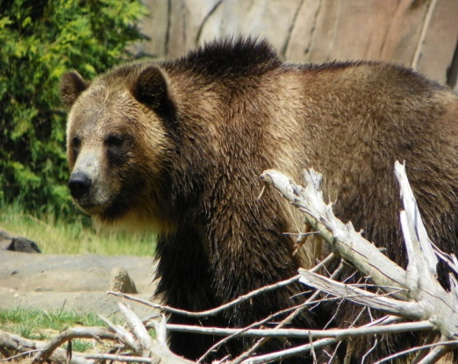

**KINDER NEWS**

February 26, 2016

**V.I.P.’s**

Aiden likes blue and red, his PS4, chameleons, chicken noodle soup and watching and listening to the rain.

Aum likes video games, red, chicken, going to Disneyland and waterparks.

Ethan likes eating sushi, going skiing, playing with dogs and drawing circles.

Olivia likes the color purple, riding horses, chocolate, cats and playing with her friend Catie.

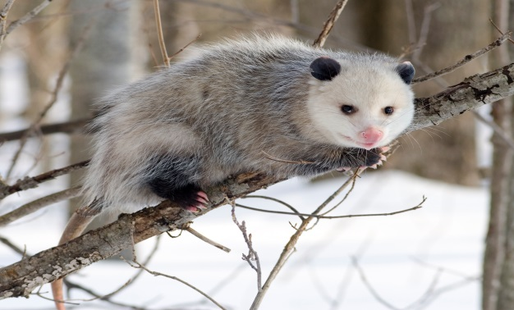

**TREE HOMES**

We have started our two week unit on tree homes. We went on a walk to look at trees and the children labeled a picture with the parts. Labeling is one of the language art standards that we are teaching. We also learned about bears and opossums this week. We hope that you will let the children share some of the facts that they have learned about these animals. The children should be able to tell you about the physical characteristics of these animals as well as the food they eat, their enemies, how they protect themselves and the young babies of these animals. The children will have lots to tell you. Enjoy!

**WORD OF THE WEEK: all**

A-l-l spells all, a-l-l spells all

all, all

We all fall down

A-l-l spells all, a-l-l spells all

all, all

We all fall down

**LANGUAGE ARTS SKILLS**

We started Unit 8 this week with our Tricky Words. The 6 words for this week are *the, a, of, all, from, have*  and *one.* We also started in a new reader, Sam, and the stories are getting longer. We hope you are reading the paper copies that are being sent home in your child’s homework. If they can read these stories once a day, they will continue to become awesome readers.

**MATH**

We continue our work with subtraction. The children are using drawings and then crossing off a part and recording with a subtraction equation as well as a number bond. We continue to work with our fluency in simple addition to 5. Thanks for helping your child with their homework.

**REMEMBER NEXT MONDAY IS OUR SPELL-A-THON TEST! WE HAVE BEEN PRACTICING HARD.**



**Kinder News**

**April 1, 2016**

**BEE UNIT**

We started our two week unit on insects. We are having fun learning about bees. This week we learned about the characteristics of an insect: three different body parts (head, thorax, and abdomen,) as well as the fact that insects have six legs and two antennae. Bees also have five eyes, two compound eyes and three simple eyes, as well as four wings and a long tongue called a proboscis. They also learned that bees live on all the continents of the world except for Antarctica. We hope you look forward to seeing more bee information next week.

**LANGUAGE ARTS SKILLS**

We started Unit 9 this week with our Tricky Words. The 4 words for this week are *when, word, why,* and *to.* We also started in a new reader, Zack and Ann, and the stories are getting longer. We hope you are reading the paper copies that are being sent home in your child’s homework. If they can read these stories once a day, they will continue to become awesome readers.

**WORD OF THE WEEK: THEY**

T-H-E-Y, T-H-E-Y,

T-H-E-Y spells “they, they, they”.

Oh, why oh why, don’t they go

away now?

“They” is spelled T-H-E-Y!

**MATH**

We started out next math module this week. We will continue to work with our fluency in simple addition and subtraction to 5. We will also be working with composing and decomposing numbers from 11-20. Thanks for helping your child with their homework.

**MACHADO FIELD TRIP**

Remember that the fieldtrip for Mrs. Clark’s and Mrs. Smith’s class is on Thursday. April 7th. Remember that they will need to bring a lunch that day and also a water bottle for drinking. Remember to layer the clothes for the children.

**KINDNESS COUNTS**

We continue working on helping the kinders make good choices and being bucket fillers and trustworthy friends. We want them to be upstanders when they see a friend being bullied. We want you to emphasize this with your children as well and talk to them about keeping their hands to themselves.



**Kinder News**

**March 27, 2015**



**V.I.P.’s**

**Joshua Bird** likes electronic robots, red, chocolate cupcakes, race cars and monster skateboards.

**Lilia** likes *Frozen*, vanilla ice cream and all kinds of horses.

**Makayla** likes #200, pizza, My Little Pony and the colors pink and purple.

**BEES**

We continued our study of bees this week. We learned the term metamorphosis. The kinders should be able to talk about the egg, larva, pupa and bee. We also learned that the only job of the queen bee is to lay eggs all day. We talked about some of the predators of the bees (skunks and bears).

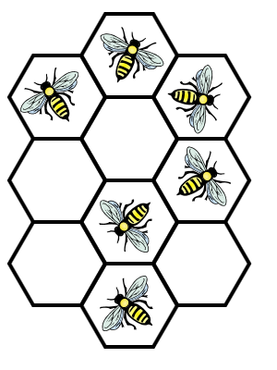

**LANGUAGE ARTS SKILLS**

We finished up Unit 8 this week and are so impressed with the reading that the children are doing. They have worked hard on digraphs (ck, ng, qu, sh, ch, th) as well as the sounds for double letters (ll, ss, zz, mm, ff). We started Unit 9 this week with our Tricky Words. The 4 words for this week are *when, word, why,* and *to.* We also started in a new reader, Zack and Ann, and the stories are getting longer. We hope you are reading the paper copies that are being sent home in your child’s homework. If they can read these stories once a day, they will continue to become awesome readers.

**MATH**

We started out next math module this week. We will continue to work with our fluency in simple addition and subtraction to 5. We will also be working with composing and decomposing numbers from 11-20. Thanks for helping your child with their homework.

**Remember** the kinders only have school next week Monday-Thursday. Friday is the first day of their spring break. If you haven’t turned in you report card envelope, please do so. Also, please get the field trip permission slips turned in as soon as possible.

**Kinder News**

**May 1, 2015**

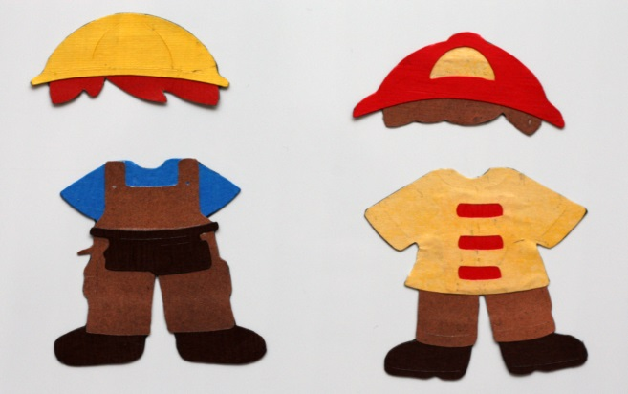

**COMMUNITY HELPERS**

We finished up our unit on community helpers and occupations. They have learned about different types of job. We finished off our unit with the ice cream and pancakes shops. The children were so excited about doing a job in the different shops. We appreciate you making the effort to come and support your child. We hope you enjoyed it as much as we did.

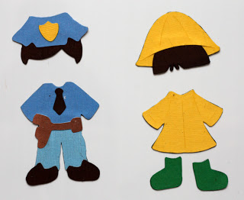

**LANGUAGE ARTS SKILLS**

The new Tricky Words for this week are: *are, were, here,* and *there.* We encourage you to work on these words with your kinders because they do not follow the sound rules and your child needs to be able to recognize these words by sight. Making flash cards and playing games with them would be a great way to help them master these words. We also want to encourage you to have your children read the copies of the stories that

are sent home in your child’s homework. If they can read these stories once a day, they will continue to become awesome readers.

**MATH**

We continue to work hard in math. We are practicing counting by tens. When we say the Tens Way it goes like this:

ten 10

2 tens 20

3 tens 30

4 tens 40

5 tens 50

6 tens 60

7 tens 70

8 tens 80

9 tens 90

10 tens 100

We have also started to work with the children on filling in missing numbers as well as counting up and then counting down from a given number. These are also things that you can work on with your child while driving in the car.

**LISTENING AND LEARNING**

We continued our study of colonial towns. We have been learning about cobblers, blacksmiths, millers, hatters, dressmakers and bakers. See if your child can tell you about the jobs that these people did.

**Kinder News**

**May 13th 2016**



**HOW DOES YOUR**

**GARDEN GROW?**

This week we studied the way That we would prepare The ground for a garden and the growth of a flower. We made a fun new book to read that they took home on Open House night and we made some beautiful gardens in the classrooms. Be sure and let your children read these good books that they are making at school.

**OPEN HOUSE**

What a wonderful sight to watch our efficient and competent “Tour Guides” sharing their rooms with the people who care about them. We hope you enjoyed yourselves and learned a lot during your visit.

Thank you for so generously supporting your children and their hard work by attending this special evening. The message you give them is . . .

“SCHOOL IS IMPORTANT”

We thought it was fun to have the food trucks there so that we could enjoy having dinner and dessert together as a community.

**YEARBOOKS**

The yearbooks will be distributed the last week of school. We will let the children sign them during choice time but they may only bring their yearbooks out when their teacher says it is okay. If you have not ordered a yearbook and would like one, we would encourage you to fill out the form quickly as they will sell out.

**LEVELED READING BOOKS**

If your child has a set of leveled reading books, please return them as quickly as possible.

**WORD OF THE WEEK: DO**

**Kinder News**

**May 29th 2015**

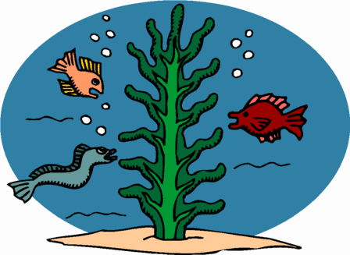

**Deep Blue Sea**

This week we started our study of the creatures of the sea. The children have been enjoying learning about the different attributes of the crab, the sea turtle, the whale, the shark and the jellyfish. They will be bringing home their book entitled In My Ocean. Be sure and let them share this book with you.

**Yearbooks**

The yearbooks will be distributed on Monday, June 1st. We will let the children sign them during choice time but they may only bring their yearbooks out when their teacher says it is okay. If you have not ordered a yearbook and would like one, there will be some copies available to buy after school on Monday. The price will be $20.00 per book.

**Next Week Activities**

We wanted to remind you that our end- of- the- year performances will be on Wednesday, June 3rd, in the individual classrooms. The performances will start at 9:45. The school has numerous activities going on that day so be sure and allow yourself time to find parking and get checked in at the office. Be careful where you park your vehicle so that you will not be ticketed.

On Thursday, all of the kinders will be attending on the 9:30 to 12:45 schedule. It has been a wonderful year and we have enjoyed your amazing children.

**IMPORTANT MESSAGES:**

Mrs. Clark’s Kinders need to return their dice from the dice game**.**

We will be sending home part of the workbook that was not completed in class. Use it well!