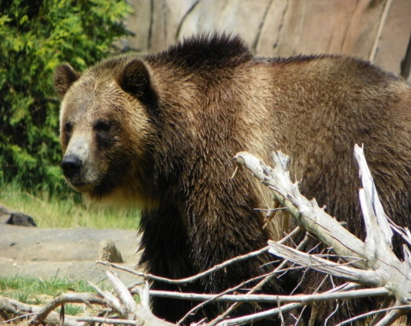

KINDER NEWS
February 26, 2016
V.I.P.’s
Aiden likes blue and red, his PS4, chameleons, chicken noodle soup and watching and listening to the rain.
Aum likes video games, red, chicken, going to Disneyland and waterparks.
Ethan likes eating sushi, going skiing, playing with dogs and drawing circles.
Olivia likes the color purple, riding horses, chocolate, cats and playing with her friend Catie.

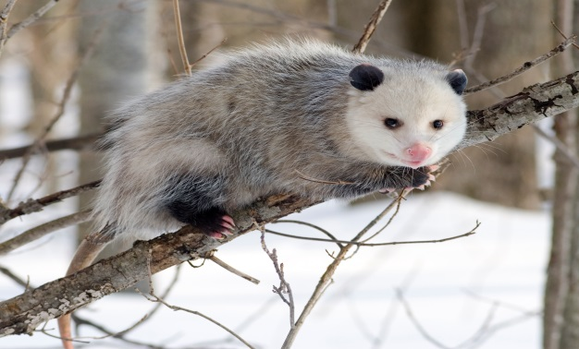

TREE HOMES
We have started our two week unit on tree homes. We went on a walk to look at trees and the children labeled a picture with the parts. Labeling is one of the language art standards that we are teaching. We also learned about bears and opossums this week. We hope that you will let the children share some of the facts that they have learned about these animals. The children should be able to tell you about the physical characteristics of these animals as well as the food they eat, their enemies, how they protect themselves and the young babies of these animals. The children will have lots to tell you. Enjoy!

WORD OF THE WEEK: all
A-l-l, all, a-l-l, all
all, all
We all fall down
A-l-l, all, a-l-l, all
all, all
We all fall down

LANGUAGE ARTS SKILLS
We started Unit 8 this week with our Tricky Words. The 6 words for this week are the, a, of, all, from, have and one. We also started in a new reader, Sam, and the stories are getting longer. We hope you are reading the paper copies that are being sent home in your child’s homework. If they can read these stories once a day, they will continue to become awesome readers.
MATH
We continue our work with subtraction. The children are using drawings and then crossing off a part and recording with a subtraction equation as well as a number bond. We continue to work with our fluency in simple addition to 5. Thanks for helping your child with their homework.

REMEMBER NEXT MONDAY IS OUR SPELL-A-THON TEST! WE HAVE BEEN PRACTICING HARD.

