Kinder News
May 13th 2016

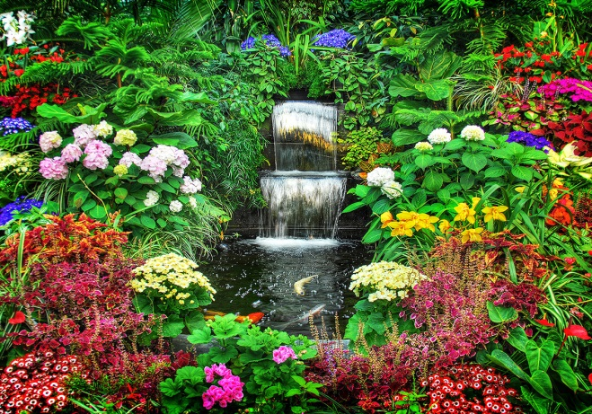

HOW DOES YOUR
GARDEN GROW?

This week we studied the way That we would prepare The ground for a garden and the growth of a flower. We made a fun new book to read that they took home on Open House night and we made some beautiful gardens in the classrooms. Be sure and let your children read these good books that they are making at school.

OPEN HOUSE
What a wonderful sight to watch our efficient and competent “Tour Guides” sharing their rooms with the people who care about them. We hope you enjoyed yourselves and learned a lot during your visit.

Thank you for so generously supporting your children and their hard work by attending this special evening. The message you give them is . . .
“SCHOOL IS IMPORTANT”
We thought it was fun to have the food trucks there so that we could enjoy having dinner and dessert together as a community.

YEARBOOKS
The yearbooks will be distributed the last week of school. We will let the children sign them during choice time but they may only bring their yearbooks out when their teacher says it is okay. If you have not ordered a yearbook and would like one, we would encourage you to fill out the form quickly as they will sell out.
LEVELED READING BOOKS
If your child has a set of leveled reading books, please return them as quickly as possible.

WORD OF THE WEEK: DO

