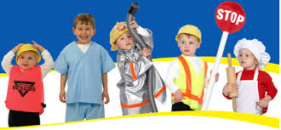Occupations:
We are having a great time learning about different community helpers. We are working on a special book called “Oh, What Can I Be?” We will share it with you on Open House.
To end our occupations unit we will open a Kinder restaurants, and learn different jobs. Please send in your RSVP’s to be our customers for this one day event.
Listening & Learning
We finished the domain about Columbus and the Pilgrims this week and are very proud of all that the students have learned! Next is the Colonial Towns and Townspeople. We compared chores from 300 years ago and now. Please consider having your child be a helper with putting away silverware, recycling, feeding pets, making their bed, and picking up their rooms. It is a great opportunity for them to contribute and learn helping skills.
Skills
We finished the last of the capital letters this week. Students should now be able to accurately trace, copy and write from memory the letters of the alphabet in upper- and lowercase form. Continue reading every day and keep an eye out for tricky words.
Math
Students continued counting from 11-20 this time in a tower configuration increasing and decreasing by 1. They practiced how to count and write as well as show and write numbers 11-20 in arrays, circular and linear configurations. The question of the week was “How many objects did you count?” Coming up: counting by 10’s to 100. Practice this with your child whenever possible, in the car, before bed, and while counting anything around the house.

