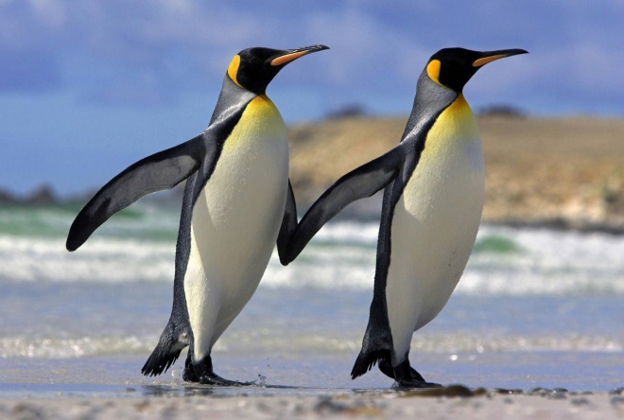
Kinder News
January 20, 2017
V.I.P.’s
Henry likes the color red, pizza, cheetah, video games and legos.
Kenzo likes pasta, cheese pizza, Iron Man, Disneyland and Mario Maker.
Sachleen likes triangles, chocolate ice cream and playing with her sister.
Brielle likes
Word of the Week Song: play
P-l-a-y play
P-l-a-y play
Let’s all play now
Let’s all play now
P-l-a-y play Hey!

Color of the Month Song: Blue
Tune: The Farmer in the Dell
B-L-U-E spells blue.
B-L-U-E spells blue.
Hi, Ho, did you know
B-L-U-E spells blue.
The big sky is blue.
The ocean is too.
Hi, Ho did you know
B-L-U-E spells blue.
Lanugage Arts
We are finishing up Unit 6 in our Amplify Series. The children should know all the letter names and sounds by this time of the year and are comfortable in blending 4 and 5 sounds in a word together. We have also been practicing on being able to hear when words rhyme. This is a fun activity for you to do in the car with them. The more they practice hearing the rhyming in words, the easier it will be for them.
PENGUINS

We have completed our two week study of penguins. The kinders have learned many new facts about this interesting bird that cannot fly. We hope you take the time to let your child talk about some of the new vocabulary/information that they have learned over the last couple of week. If you would like to watch penguins being feed, you can watch through a webcam at the California Academy of Sciences. The African penguin colony feeding happens at 10:30 am if you want to pull it up to enjoy with your child.

