V.I.P.
Ian likes killer whales, the color red, and cheese burgers.
Luke likes lions, baseball, and transformers.
Calie likes rabbits, the color purple, and the movie Frozen.
Angel- likes baseball, wii u, and the book Chicka Chicka Boom Boom.
English Language Arts
Skill Strand:
We continue to work on short vowel sounds, as well as sound spelling. We read the story “Ox and man” a decodable text, that incourporates the letter-sound correspondences that we have learned so far.
Try some chainging at home- cat>bat>bad>bid. Replace one letter to change the word and have your child tell you what sound to chaged the first, middle or last.

Listening and Learning:
In this domain students learned about several farm animals as well as crops that people grow on farms. Students will also learn how farmers meet the needs of farm animals.
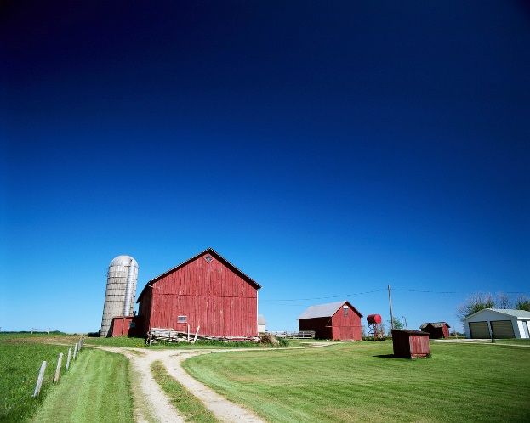

Math
We continued comparing the weight of things using heavier than, lighter than and the same as with balance scales. We began learning about volume comparing more than, less than and the same capacity.

