Kinder News
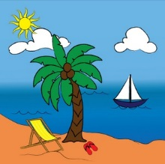
Fun in the Sun!
We had a wonderful week learning about the sea and sea creatures!
Performances:
We hope that you enjoyed our end of the year performances! We are so proud of all our hard working kiddos!
Summer Break
Have a wonderful summer break! We look forward to seeing all our big first graders in Aug.

