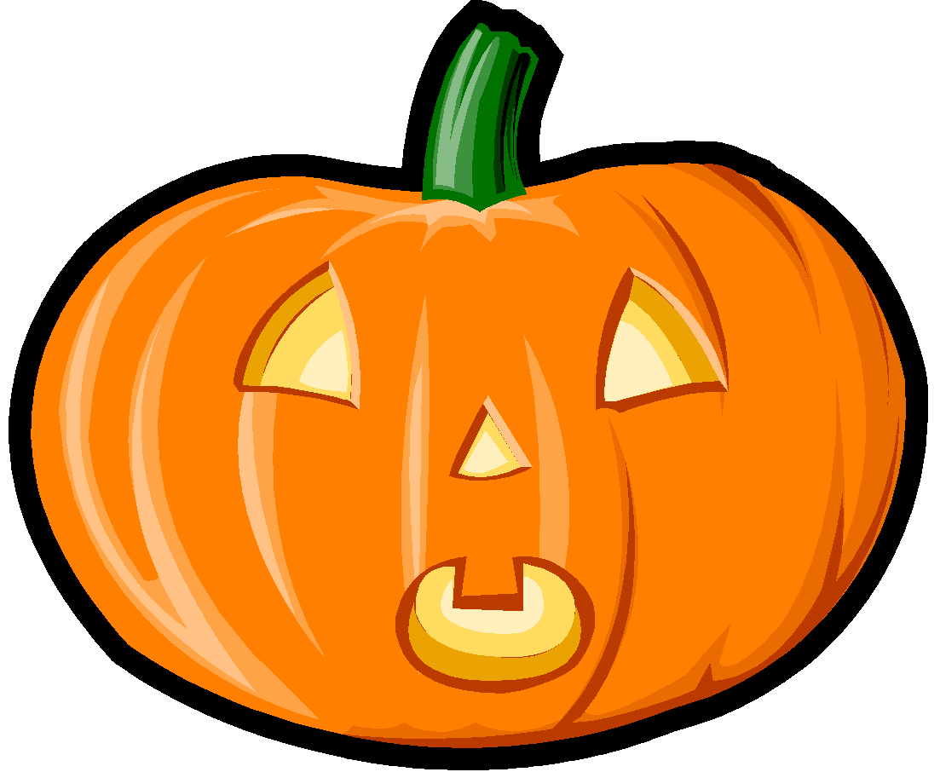
Kinder News
October 30, 2015
V.I.P.’s
Casey likes kittens, playing hide and seek, and red apples
Lydia likes the aquarium, trick or treating, and the winter season.
Ashton likes pizza, Star Wars, and the aquatic center.
Rebecca likes vanilla ice cream, dolphins, and Barbie

BONES
We talked a lot this week about the bones in our bodies. We know we have 206 bones in our skeleton. We know that some bones help our bodies move and that other bones protect our organs. We also know that as we grow older, our skeleton grows bigger. We practiced matching skeletons with their correct outer covering.

Language Arts Skills
This week we continued practicing segmenting words into phonemes. We reviewed the 16 sounds we have learned so far this year and continued reading and spelling chains of one-syllable short vowel words. We are learning to distinguish between similarly spelled words by identifying the sounds of the letters that differ, e.g., peg and pig, pin and pen. We also started reading big books where we are reading two and three word phrases. It is fun to learn these new skills.

Math
This week we have started working on the 3-D shapes cylinders, cones, cubes and spheres. We are learning how to recognize these solid shapes and also learning the positional words above, below, beside, in front of, next to, and behind.

Happy Halloween!
I hope you and your family have a fun, safe Halloween. DON’T FORGET- SET YOUR CLOCKS BACK ONE HOUR ON SATURDAY NIGHT!!
