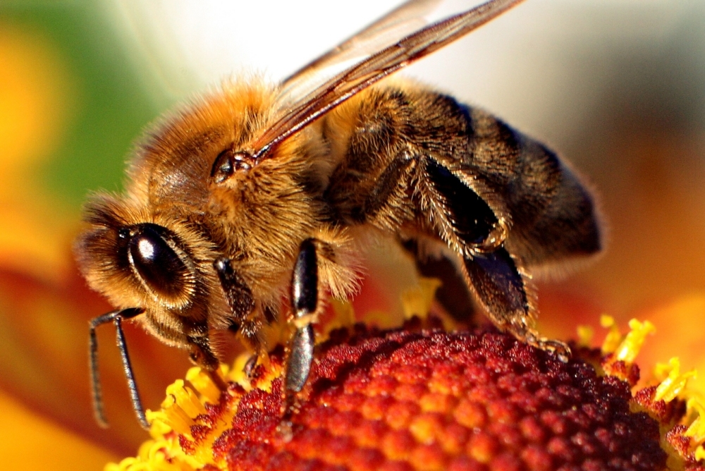

KINDER NEWS
April 8, 2016

BEE UNIT
We finished our two-week study of bees. The children learned about the Queen Bee, the four life stages, and bee predators. Your child should be able to tell you about its life cycle- “egg”, “larvae”, “pupae”, and “adult bee”. Ask us why a skunk is an especially bad enemy for the bees!

WORD OF THE WEEK: when

LANGUAGE ARTS SKILLS
We are continuing with Unit 9 this week where we have been practicing writing uppercase letters I, J, K, L, M, N, O, P, Q, and R. In addition, students have been learning tricky words, including “no”, “I”, “what”, “so”, and “where” that appear in their reading book, Zack and Ann. We hope you are reading the paper copies that are being sent home in your child’s homework. As they read these stories, their reading confidence will grow.

Math
The kinders have been working hard on their understanding of numbers 10-20. They are demonstrating their thinking through drawing Ten Frames and filling in dots, drawing dots alone, or using different types of tools in class. Students have been practicing saying numbers 10-20 using the “Say Ten” method.

ANNOUCENMENTS
There will be no school from April 11-15 for Spring Break!

