KINDER NEWS

Ally likes: pink, pizza and Elsa.
Finn likes: apples, letter Ff and cars.
Sophia likes: spotted horses, her violin and strawberry ice cream.
Kylie likes: ballet, dogs and princesses.
Apples:
This week we have been learning about apples. We integrated apples into math, language arts and science. We made class books called “Ten Apples Up On Top”.
Skills:
This week we learned about letter sounds /o/, /c/, /g/ and /i/. We learned how to draw the letter pictures for these sounds and write words that begin with these sounds.
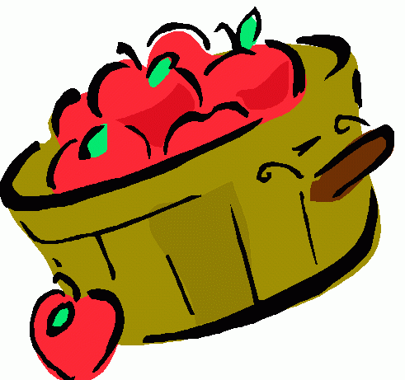
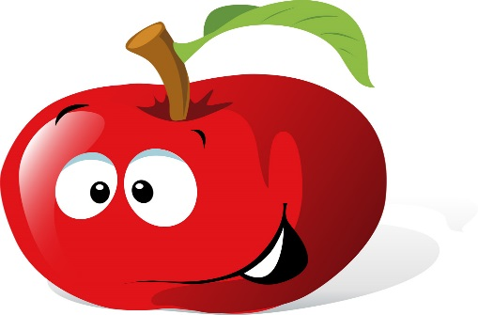
Listening and Learning:
This week we started our read aloud anthology of short stories.
Math:
This week we made combinations of numbers and practiced writing numbers 8, 9 and 10. We also practiced number stories or word problems using number combinations to add.

Don’t Forget!!
Field trip next week
Garcia/Smith Tues, Oct 6
Clark/Branch Wed, Oct 7
Bateh/Page Thurs, Oct 8

